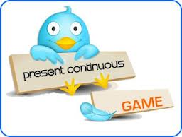

***I am***

***He***

***She is***

***It verb + ing ( writing)***

***You***

***They are***

***We***

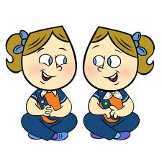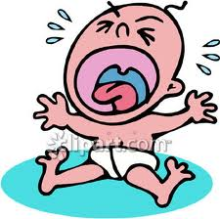

**Examples :-**

1- I am writing a story tomorrow .

2- He is going to London Next week .

3- They are visiting their friends now .

**The baby - cry – now .**

**…………………………………………………………………………………….**

**I – have - an exam - tomorrow .**

**…………………………………………………………………………………….**

**Form sentences in the present continuous using the following words:-**

**Present past simple**

***Forget forgot***

***Take took***

***Stand stood***

***Come came***

***Go went***

***Are were***

***Leave left***

***Find found***

***Write wrote***

***Is was***

Irregular simple verbs



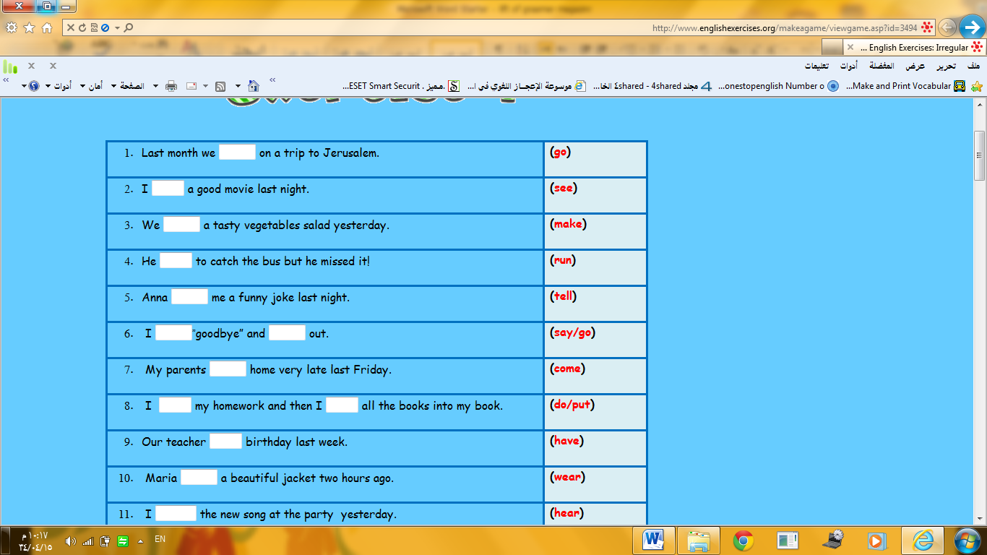

**Write the past tense of the verb**



**By and on for Methods of transport :-**

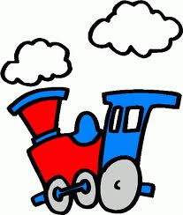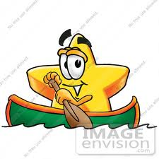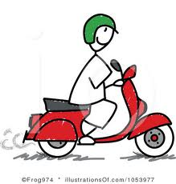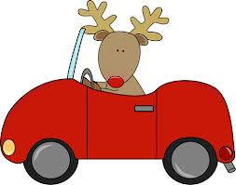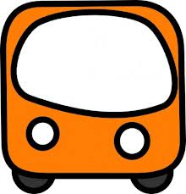

**Go by train**

**Go by scooter**

**Go by boat**

**Go by car**

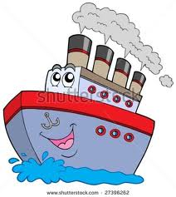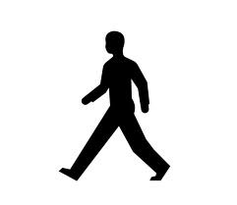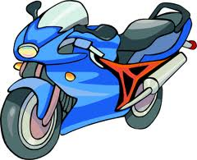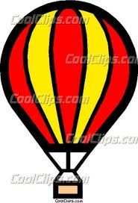

**Go by plane**

**Go by ship**

**Go by motorbike**

**Go on foot**

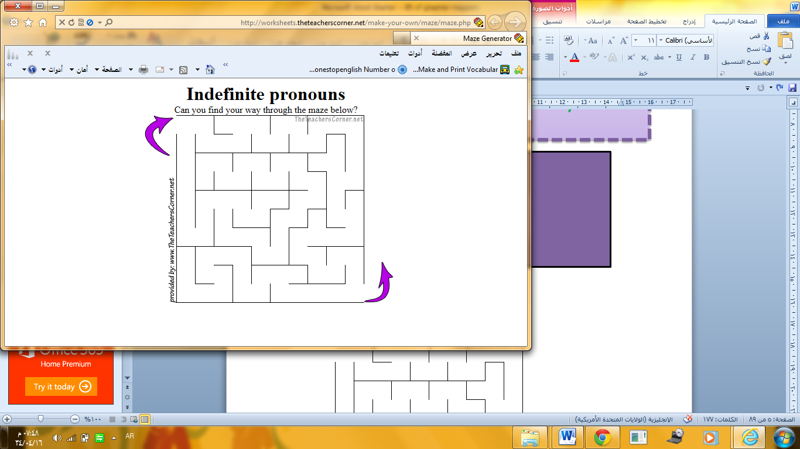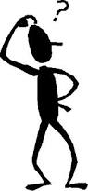

**nothing**

**Indefinite pronouns**

**Sentences negative questions**

**Someone no one anyone**

**Something nothing anything**

**Somewhere nowhere anywhere**

**Exit**

**start**

**No one**

**No where**

Examples:-

1-There is *someone* in my room .

2- Sarah finds *nothing* in her closet .

3- Did you go *anywhere* nice ?

**tall she is he**

**How Heavy it**

**you ?**

**old are we**

**they**

**am I**



**Choose the correct answer :-**

**How old *( is - are – am )* he ?**

**How tall are *( you – it – I )* ?**

**How heavy is she *( . _ ? )***

**Examples :-**

**How old are you ? I am 14 years old .**

**How heavy is she ? She is 45 kilos .**

**How tall am I ? You are 1 meter 34 tall .**

**Questions with how and adjectives**

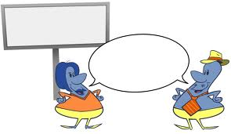

**How many countable nouns *( ex . apple , pen …)***

**How much uncountable nouns *( ex . water , salt ..)***

**How much and How manyy**

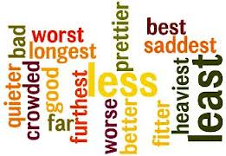****

***Write the correct form of the adjective :-***

**1-Cheetah is the ……………..( fast ) animal in the world .**

**2-Omar is the ………………… ( nice ) boy in his class .**

**3-Koala bears are the ……………..( lazy ) animals in the world.**

**Adjectives + est**

**tall + est = tallest**

**big + est = biggest**

**nice + est = nicest**

**lazy + est = laziest**

**Superlative adjectives**

**For comparing more than two**

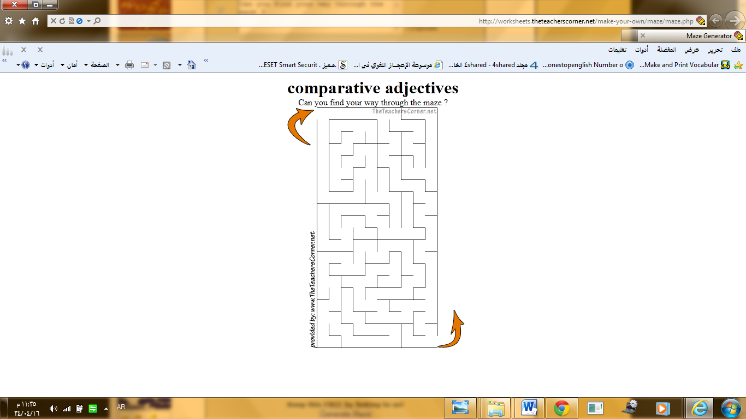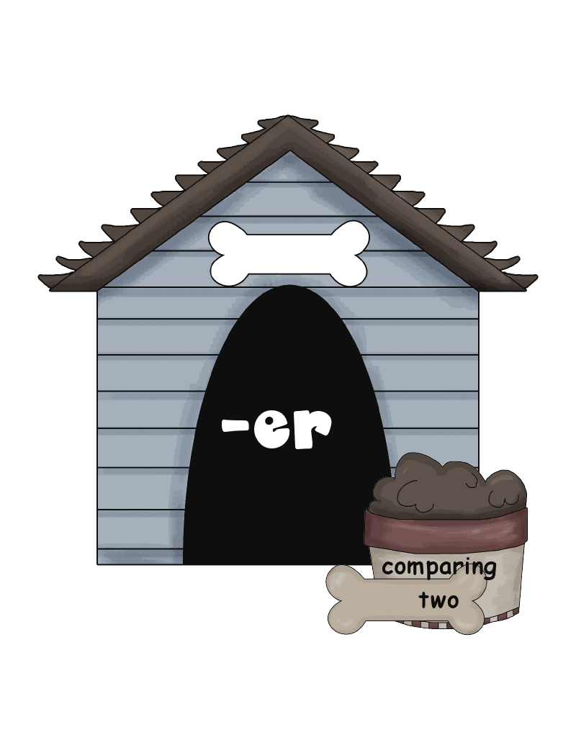

**bigger**

**smaller**

**lazier**

**Comparative adjectives**

**For comparing two**

**Adjectives + er**

**Noisy +er = noisier**

**Small + er = smaller**

**Nice + er = nicer**

**Big + er = bigger**

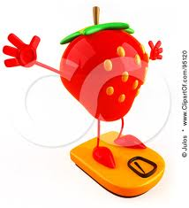

**Examples**

**What are your ( *heavy – weight* ) ?**

**How ( *heavy – weight* ) are you ?**

How+ adjectives ………?

What + noun ………?

**Questions with what and how**

**What is your age ?**

**I am 14 years old .**

**How old are you ?**

**I am 14 years old**

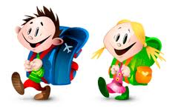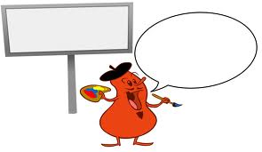****

**He will ( go – went ) to school.**

**She will (writes– write ) her homework.**

**Choose**

**He**

**She**

**It**

**They will verb ( no change)**

**You write – go**

**I**

**We**

**Future with will (1)**



**he**

**She**

**It**

**Will they verb ( go , swim ..) ?**

**you**

**we**

**I**

***Rearrange the following words:-***

**1* tomorrow - She – help - Reema – will - .**

**………………………………………**

**2* go – Will – to – school – they - ?**

**……………………………………….**

**Questions with will**

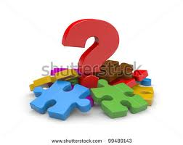

**Adjectives with preposition**

**Complete**

**1* I am annoyed ………… lazy people .**

**2* She is afraid …………. Snakes .**

**3* Fred is fond ………….. reading stories .**

**4* They are good ……….. playing Tennis .**

**Adjectives preposition**

**afraid of**

**good at**

**bad at**

**polite to**

**interested in**

**keen on**

**annoyed by**

**fond of**

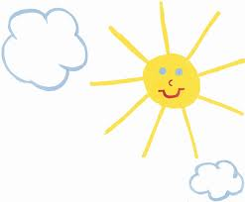

**Rearrange the following words**

**1* I'll type my essay . ( statement )**

**2* I won't type my essay . ( negative** )

I will = I'll

I will not = I won't

**Future with will (2)**

**Statements and negative**

**1* win – I-pad - I'll – an .**

**……………………………………………………………………………………**

**2* She – give up – won't** .

…………………………………………………………………….……………

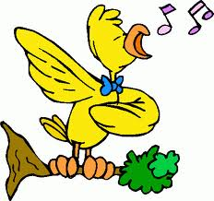

**was singular noun**

**There verb+ing**

**were plural noun**

**___________**

**Ex:- There were two boys playing football.**

**-There was a boy playing football.**

**1_ There was (a girl – girls ) cooking the meal .**

**2_ There ( were – was ) teachers standing behind the door.**

Choose

**There were –was and verb +ing past simple and past continuous**

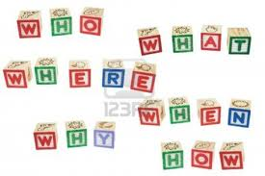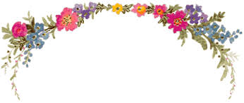

**(متى)When**

**(من)Who**

**) ماذا) What**

**(لماذا) Why**

**Wh- questions**

**Complet**

**4_........does he meet at school?**

**1_.......does Lucy like to eat?**

**3_.......do they want to travel?**

**2_.......do you sleep?**



Examples:-

-I not only *eat* vegetables but also fruits .

-Reema not only *speaks* Arabic but also English .

Form in the correct order :-

1_ writs – not only – essay – He – stories – but also .

………………………………………………………………………………………………..

2_ You – but also – read – books – not only – poems .

………………………………………………………………………………………………

**Not only ………But also**

Subject (He , I) not only v (present simple) but also n ثقلاHe,Lucy,I..) not only vr t

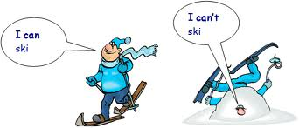

Choose

**I (can-can't) ski .**

**I (can-can't) ski .**

**Examples**

**1-For centuries people could travel by horses .**

**2-Pilgrims can fly to Jeddah now.**

**3-People will be able to travel to Makkah by train soon** .

**past**

**present**

**future**

**(the ability to do things )**

**Can**

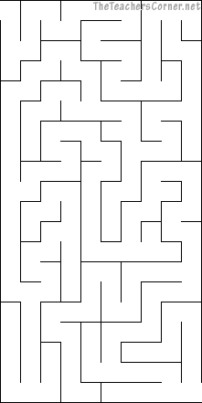

**window**

**Exit**

**close**

**start**

**Shall**

**Shall**

**( to make offers)**

**Form the question through the maze**

**the**

**you**

**?**

*Examples*

* ***Shall*** you turn the TV on?
* ***Shall*** he go to the library?

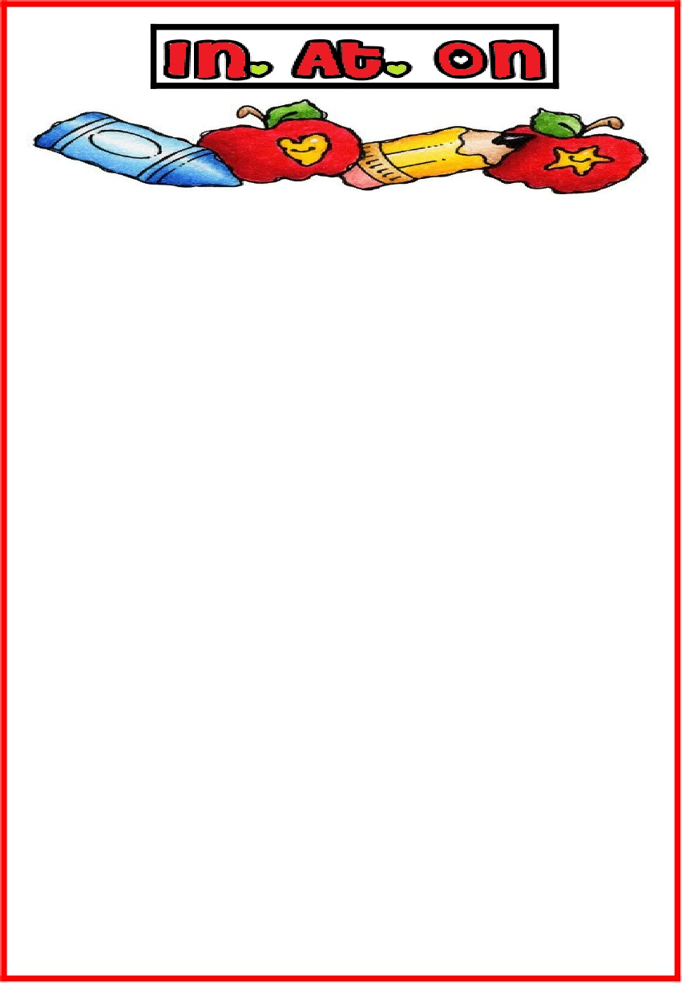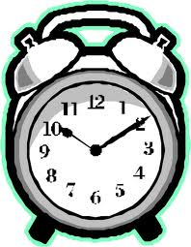

**Choose**

1_ you have to sleep ( in – on – at ) ten o'clock.

2- We are going to the gem ( in – on – at ) Monday .

3_ She will graduate ( in - -on – at ) 2014 .

**on + day or date**

**He sleeps at 9:00 p.m.**

**at + time**

**We will go to school on Sunday.**

**I went to Jeddah in April .**

**In + month or year**

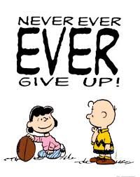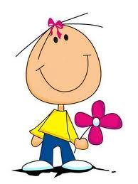

**Never and Always**

**Complete with Always or Never**

**1-………….………….. play with fire .**

**2-…………..……………… drink water.**



Choose

1_ What about ( eating – eat ) in a restaurant .

2_ Shall we ( drink – drinking ) coffee .

3_ Let's ( having – have ) party .

Let's

Shall we have

What about some tea?

How about having

Ex:- *What* about having a party?

**Suggestions**

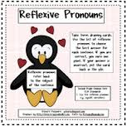

Rearrange the words :-

She – herself – read- by – a story - can .

………………………………………………………………

**I myself**

**You yourself**

**He himself**

**She herself**

**We ourselves**

**They themselves**

**It itself**

**They are pronouns that come after verbs**

**EX ;-Nina makes herself some tea .**

**I hurt myself .**

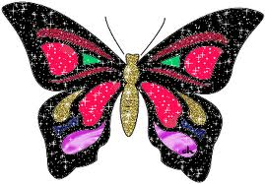

**past**

**Clauses with When**

**Future – past - imperative**

**Imperative**

**future**

**Choose**

**1_ When we go to school , we ( said – will say ) hi to our friends.**

**2_ When you arrive at London , ( called – call ) me .**

When you entered your room , you cleaned it .

When you enter your room , you will clean it

When you enter your room , clean it.

**Choose**

1_ Saudi Arabia is the (most-more) important country in the world.

2_ Fred is (fewer-fewest) fluent than Omar .

Examples

-*Nina* is most beautiful girl in the class*.*

- *English* is fewest difficult subject .

2_ comparing more than two

Examples

-*Nina* is more beautiful than *Reema.*

-*Riyadh* is fewer crowded than *Egypt*

**Tip**

**Long adjectives are words that have more than one syllable**

**Comparison**

**For long adjectives**

Examples

Beautiful - crowed – difficult – important …….etc

**Fewer – fewest**

**For countable nouns**

**للمعدود**

1_ comparing between two

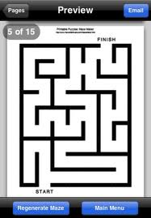

**Find your way through the maze using the letters**

**a**

**h**

**W**

**How was the trip?**

**What was the trip like?**

**Description**

**Character**

**Appearance**

**What does the new girl look lik?**

**How are you?**

**Health**

**t**

**Uses of How and What**

**What is your teacher like ?**

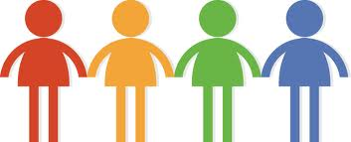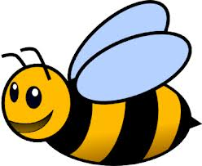

**Very ……….**

**Very ……….**

**quite big**

**big**

**very big**

**not very small**

**quit small**

**very small**

**Small**

Modification of adjectives



**She has to sleep early .**

**Muslims have to pray five times a day**

**Choose**

1_ Muslims ( has – have ) to fast Ramadan.

2_ He ( has – have ) to write his homework .

3_ I ( has – have ) to go now.

4_ In Saudi Arabia we ( has – have ) to take off our shoes when entering the house.

**(for necessity)**

**have to – has to**

**(for obligation)**

|  |  |
| --- | --- |
| countries | Nationality |
| Egypt | Egyptian |
| England | English |
| Morocco | Moroccan |
| Italy | Italian |
| France | French |
| Japan | Japanese |
| Germany | German |

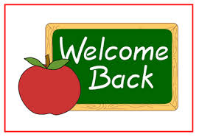

-This is an ( Egyptian – Egypt ) gold coin .

-It's a ( Morocco- Moroccan ) door .

**Countries and Nationalities**

**Order of Moltiple adjectives**

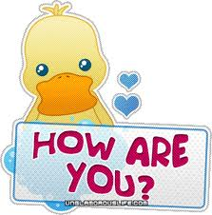

**Rearrange**

1. **ADJECTve**
2. **the place**
3. **what the thing made of**

**wood – small – It’s – a – book – Italian**

**………………………………………….**

|  |  |
| --- | --- |
| Articles | |
| Definite | **Indefinite** |
| the | a, an |

(Note )

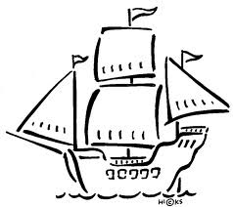When we are talking about one thing in particular, we use **the**. When we are talking about one thing in general, we use **a** or **an.**

**Examples**

**The sun**

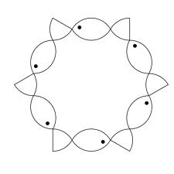

**1_ ( The – a ) moon .**

**2_ That is ( the –an ) orange**

**There is a cat in my room.**

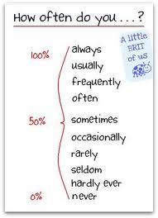

**Examples**

1_ I always pray five times each day.

22_ She Often read a story .

3_ They rarely travel by car .

**Adverbs of frequency**

**Sentenses with gerund subjective**

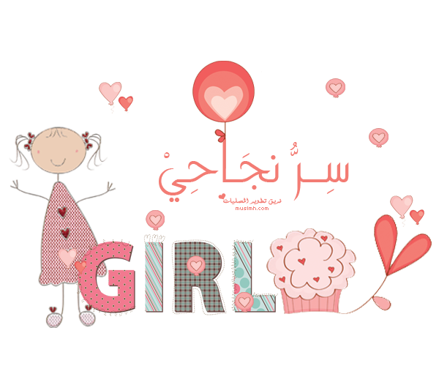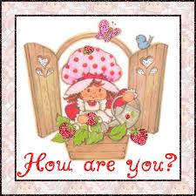

**Subject like verb + ing**

**I *like* reading .**

**Subject think verb + ing**

**I *think* going to bed late isn't a good habbit.**

**Correct the verb in brackets :-**

1_ She like ……..….. ( drink ) coffee .

2_ I think ……….( swim) is a good sport.



Rearrange the following words :-

1_ she– If–water –heats- , -boils – it .

………………………………………………………….

2_ If - salt - put- we - in – water- , - melts – it .

……………………………………….

**We use it for true result**

**Zero conditional sentences**

If condition , result (present - imperative)

Examples :-

- If you heat ice , it *melts* .

- If people don't eat , they *get* hungry .



Choose

1_ The story is ( more – most ) interesting than the poem.

2- Sara is the ( less - least ) nervous in the class .

3_ Arabic is the ( more – most ) difficult language.

**Comparison for long adjectives**

**Examples**

**-Lama is more generous than Sarah.**

**-Omar is less nervous than Fred .**

**Examples**

**-Fatimah can answer the most questions.**

**-I drink the least milk in my class .**

**2-Comparing for more than two**

**1-Comparing for two**

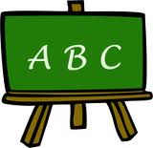

***Have to* (past)**

**For obligations and necessity**

**have to = had to**

Examples

**_ I had to finish my homework last night.**

**_ I was ill yesterday , I had to sleep early**.

**Complete the sentences**

**1_ I ………….. to study my exam last Monday .**

**2_ I ………………… to sleep early tonight** .

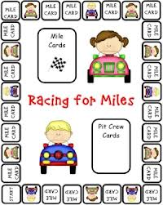

**Verb + verb-ing (1)**

**Revision of adjectives**

Subject verb (present simple) v+ing

Examples

I like playing football .

She likes swimming.

Choose

I like ( play – playing ) Tennis .

Correct the verb

He ….…….( like) eating fruits.



Give the opposite

Possible x ………………………..

Helpful x ……………………….

Kind x …………………………

Sure x …………………….

**Un-**

**Opposite adjectives**

**With prefixes**

Tidy – untidy

healthy – unhealthy

fit – unfit

sure – unsure

Helpful – unhelpful

fashionable – unfashionable

safe - unsafe

Successful – unsuccessful

kind – unkind

Intelligent – unintelligent

important – unimportant

usual - unusual

**im-**

Polite – impolite patient – impatient

Possible – impossible probable – improbable

** Verb + verb-ing (2)**

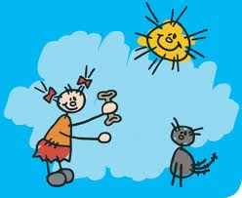

Form the words

1_ She - breakfast –is - egg –for- having - .

…………………………………………………………………………..

2_ are – What – drinking –they – at- dinner- ?

…………………………………………………………………………….

1_ How are you travelling ?

I am travelling by train .

2_ What is he having at lunch ?

He is having a sandwich at lunch .



Can you write the adverbs of frequency ?

…………………………………………………………….

……………………………………………………………..

……………………………………………………………..

……………………………………………………………..

……………………………………………………………..

.

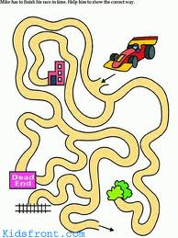

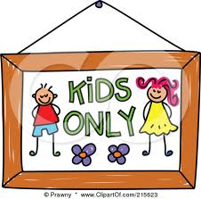

Write different methods of transportation

……………………

……………………

……………………

……………………

……………………

……………………

……………………

……………………



**I hope you had fun**

**T.Ghadah Al-Mutery**

Lift off 4

Grammar magazine

**T. Ghadah Al-Mutery**

**Published by**

**46th Intermediate school**

**GRAMMAR TIME**

**Stop**