**Math 101_Homework# 1 : Functions**

**Problem 1:** Simplify: (a)  (b) 

**Problem 2:** If  and 

Find a formula for ** simplifying your answer as far as possible.

**Problem 3:**  Use the definition of a logarithm to evaluate each of the following.

a) log88 = _____ b) log644 = _____ c) log1 = _____ d) $ln{ e}^{3}$ = _____

**Problem 4:** Find the domain of the following functions:



$f\left(x\right)=\sqrt{2x-1}$

$f\left(x\right)=\frac{x-2}{x^{3}-3x}$

**Problem 5:** Select all of the following graphs which are **one-to-one functions**.

a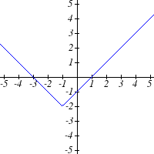 b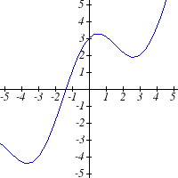 c 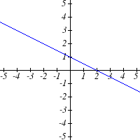

**Problem 6:** Find the inverse of the following functions:

1.  2. 

**Problem 7: If** . Find:

1. $g(-2)$.
$f\left(g(x\right))$

2. $2f\left(-2\right)-3g(1)$.